White Memorial
Presbyterian Church

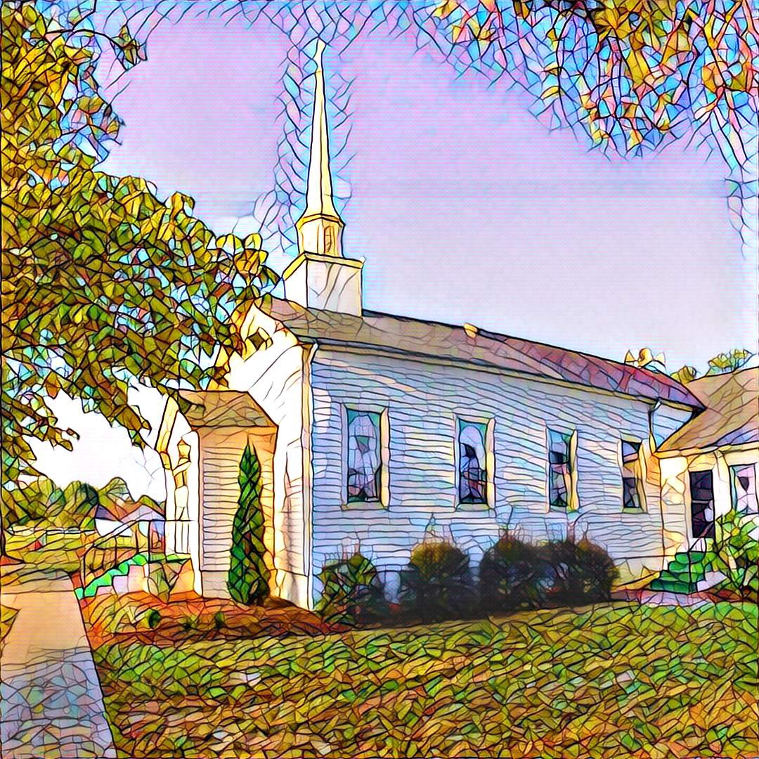

1459 White Memorial Church Road - Willow Spring, NC 27592
www:wmpcwillowspring.org

Remembering God’s Grace,

the mission of White Memorial Presbyterian Church in Willow Spring is:
Come to be joyous and thoughtful in worship;
Walk with God’s guidance into deeper faith and knowledge;
Stretch out to the needy with tangible acts of service;
Be loving and generous with time, talents and treasures;
Go out into the world to welcome and invite.
The Service for the Lord’s Day
24th Sunday after Pentecost
White Memorial Presbyterian Church

The Church Gathers
November 8, 2026 10:30 AM
*Please rise in body or spirit.

Prayer for Preparation:
God! Please hurry to my rescue! God, come quickly to my side! Quick to my side, quick to my rescue! God, don’t lose a minute. (from Psalm 70 The Message)

Prelude –

Welcome and Announcements

*Call to Worship (Psalm 78)
One: Give ear, O my people, and listen to the words of my mouth
All: We will tell the coming generations of the Lord’s glorious deeds and the wonders God has done.
One: Let us set our hope in God and not forget the works of the Lord.
All: As we wait, we will tell the story and keep the commandments.
One: We come together to worship the living God.

*Opening Hymn - #41 O Worship the King, All Glorious Above

Prayer of Adoration

Call to Confession
Confession and Pardon

Unison Prayer of Confession
God of grace, we have sinned against you by not honoring you or loving one another.
We sleep when you ask us to be awake. We fall short in our preparations for the delays that inevitably come.
We fail to share what you have provided. We have lost our hope.
Forgive our sinful ways, tame our wayward wills and make us more like Christ.
Inspire us by your Spirit so that we will be prepared to welcome the Lord when he appears.
May our lives here and now be a glimpse of what we hope all may one day enjoy.

Assurance of God’s Forgiveness
One: Friends, hear these words, and listen to this good news: Jesus died and rose again, and will bring with him both those who have died and those who are alive.

All: In Jesus Christ, we are forgiven, thanks be to God.

We Proclaim God’s Word

Prayer for Illumination
One: Inspire us by your Holy Spirit that the words we read on the page might become living words in our hearts and lives as we encounter the grace, love and peace of Jesus Christ. Amen..

Scripture Reading: Isaiah 6: 4-8 & Mark 1: 16-20

Sermon: - "Jesus Is Calling You To Ministry"

* Affirmation of Faith (The Apostles’ Creed)
I believe in God, the Father Almighty, the Creator of heaven and earth,
And in Jesus Christ, His only Son, our Lord, who was conceived of the Holy Spirit,
born of the Virgin Mary, suffered under Pontius Pilate, was crucified, died, and was buried.
He descended into hell.
The third day He arose again from the dead. He ascended into heaven and sitteth at the right hand of God the Father Almighty, from whence He shall come to judge the living and the dead.
I believe in the Holy Spirit, the holy catholic church, the communion of saints, the forgiveness of sins, the resurrection of the body, and life everlasting.
Amen.

*Hymn of Response - # 157, I Danced in the Morning

Sharing of Joys and Concerns

Prayers of the People
Our Father who art in heaven, hallowed be thy name. Thy kingdom come, thy will be done, on earth as it is in heaven. Give us this day our daily bread; and forgive us our debts, as we forgive our debtors; and lead us not into temptation but deliver us from evil. For thine is the kingdom and the power and the glory, forever. Amen

Reception of God’s Tithes and Our Offerings

Offertory

*Doxology

*Prayer of Dedication
Going Out in God’s Name

*Hymn of Commitment - # 726, Will You Come and Follow Me

*Charge and Benediction

*Postlude

Leading in Worship today
John Etheredge, QRE
Kristy Gathings, musician

Nancy Warren, Commissioned Ruling Elder, flagman22@embarqmail.com
Staff- Charlene Wilson, Church Secretary, WMPCoffice@WMPCwillowspring.org
Upcoming Services at WMPC
November 15th Rev. Jeff Kisner
November 22nd Rev. Joy Alford
November 29th Nancy Warren, CRE
- Hanging of the Greens

Announcements

- Presbyterian Women will meet at noon on Monday, November 9th, in the fellowship hall. Please bring a covered dish to share for lunch.
- Senior lunch is Thursday, 12th November at Mt. Zion. Please let Margaret King know if you plan to
attend

- Our next Nourish Worship is Tuesday, November 24th at 5:30 PM. All are welcome at the table!
- Ahead of the World Day of Remembrance for Road Traffic Victims on Sunday, November 15, please pray for the families and friends of the 1,524 people killed in traffic crashes in North Carolina last year. And please pray that we will all show one another love and care by always being safe and responsible on the road.

Public Prayer List
Prayer concerns may be submitted by turning in a prayer request card in the offering plate or by contacting Glenda Talton via phone or email.

Congregation:

Roger Gossett, Jan Gossett, Pat Patrick, Jim and Trish Shannon, Ann Stephenson, Jerry and Jane Smith, Linda Strickland, Teresa Smith, Sandy Parrish, Nancy Warren, Mary Jane Dunn's eye surgery was successful, Carole McCartney.

Family/Friends:
Ruth Dupree, Paulette Greer (Margaret), Lee Anne Simmons (Anne Honeycutt), Darlene Martin (sister of Sharon Guss), Lissette and her autistic son are having difficulties(Sharon Guss), Pam Denning, Linda Penny (Don),Cathy Cotton (Carole), Rev. Joy Alford's friend Kelly's daughter, Lil Ortney (Don and Teresa). David Holt (Teresa), Michelle Martinez (Trish), Nancy Appleby (Mary Jane’s friend).

Marie Holding (Joyce Byrd’s sister) did require additional back surgery and will be returning to BellaRose in Garner for rehab.

Joys

Betty Hilda Collins celebrated her 95th birthday.

Teresa and Don Smith celebrated their 42nd anniversary on November 4th.

