White Memorial
Presbyterian Church

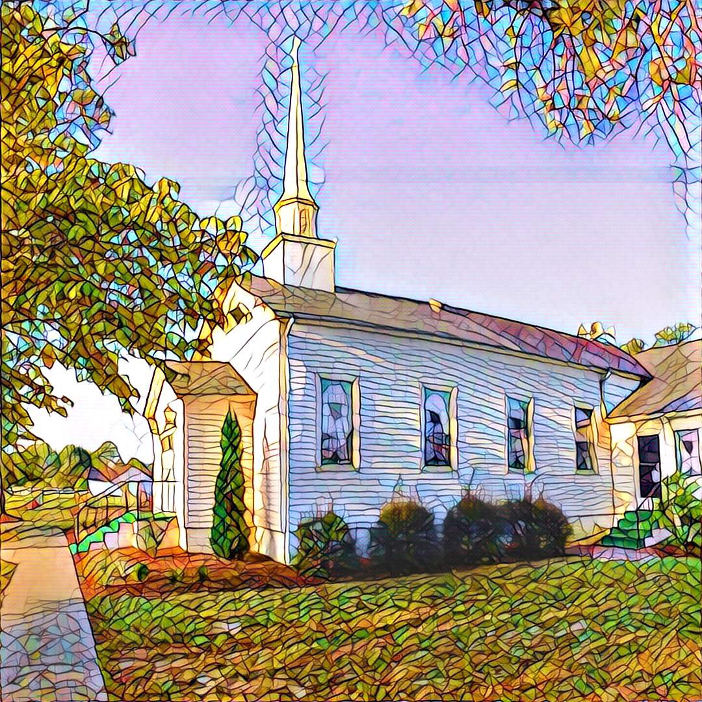

1459 White Memorial Church Road - Willow Spring, NC 27592
www:wmpcwillowspring.org

Remembering God’s Grace,

the mission of White Memorial Presbyterian Church in Willow Spring is:
Come to be joyous and thoughtful in worship;
Walk with God’s guidance into deeper faith and knowledge;
Stretch out to the needy with tangible acts of service;
Be loving and generous with time, talents and treasures;
Go out into the world to welcome and invite.
The Service for the Lord’s Day
Twenty-First Sunday after Pentecost
Liturgical Color – Green
White Memorial Presbyterian Church Homecoming

The Church Gathers
October 18, 2026 10:30 AM
*Please rise in body or spirit.

Prayer for Preparation:
God of justice, you are at work this very day on behalf of those who are poor, marginalized, and disregarded. Fill me with the power of your Holy Spirit so that I can begin this day praying earnestly for someone who faces injustice. Help me to see and to act upon an opportunity to participate in your love and justice. Give me the eyes and ears of faith as I go about my daily routines, walk the paths and hallways of my daily life, and attend to news local and global. Then, seeing and hearing through the light of Christ, encourage me relentlessly to pray and work without losing heart. I ask it in the name of Jesus. Amen.

Prelude - Amazing Grace (My Chains Are Gone) by Tomlin and Giglio Kristy Gathings
Welcome and Announcements

*Call to Worship
One: Each morning, God's grace awakens us, each evening, God's peace cradles us.
All: Compassion is our constant companion, as we go through work, school, the day.
One: In every moment, God is present with us; God whispers words which can change our lives.
All: Justice is our faithful teacher, pointing to where we can carry out fairness.
One: When we find ourselves groping in the shadows, God's light will provide a way home.
All: We turn the corner, and hope is waiting for us; we return home, and find a feast
prepared.

*Opening Hymn – #396 “Brethren, We Have Met to Worship”

Prayer of Adoration
Confession and Pardon

Call to Confession

Prayer of Confession
All: Great Lover of Justice, hear our prayers: we are called to treat all people equally, yet we take sides and pick favorites; You have chosen us to be your children, yet we arrogantly assume others are not so honored; You challenge us to be examples of faith, and often we reveal our worst natures to our families and friends. Forgive us, Giver of Rest. Enable us to stop putting you to the test, so we can open our hearts to your healing touch of compassion and hope. As Jesus Christ, our Lord and Savior, has given all for us, may we give ourselves to You - confidently, completely, faithfully. ………..
(Please observe a moment of silent confession).

Assurance of God’s Pardon
One: Hear the good news: the One who created goodness and beauty is also the One who shows no partiality, but offers grace and peace to all.
All: God has heard our prayers and done the very thing we asked - forgiven us, healed us, restored us. Thanks be to God. Amen.

Anthem How Great Thou Art vocalist Mallory Young

We Proclaim God’s Word

Prayer for Illumination
All: Let us pray: Gracious and living God, Your Word is a lamp to our feet and a light to our path. As we gather on this homecoming Sunday, surrounded by memory and promise, shine your light upon the Scriptures we are about to hear. By your Spirit, open our hearts to receive your truth, our minds to be renewed by your wisdom, and our lives to be shaped by your love. Through Jesus Christ, our hope that does not disappoint, we pray. Amen.

Scripture Reading Psalm 119:105; Romans 5:1–5

One: This is the Word of God for the people of God.
All: Thanks be to God

Sermon - “A Lamp for Our Feet, A Hope That Does Not Disappoint” Rev. Ed Johnson

*Affirmation of Faith: Apostles’ Creed
All: I believe in God the Father Almighty, Maker of heaven and earth. And in Jesus Christ, his only Son our Lord; who was conceived by the Holy Ghost, born of the Virgin Mary, suffered under Pontius Pilate, was crucified, dead, and buried; he descended into hell; the third day he rose again from the dead; he ascended into heaven, and sitteth on the right hand of God the Father Almighty; from thence he shall come to judge the quick and the dead. I believe in the Holy Ghost; the holy catholic church; the communion of saints; the forgiveness of sins; the resurrection of the body; and the life everlasting. Amen.

*Hymn of Response #435 - There's a Wideness in God's Mercy

Sharing of Joys and Concerns

Prayers of the People and the Lord’s Prayer

Reception of God’s Tithes and Our Offerings

Offertory “Thy Word" by Michael J. Smith and Amy Grant Anne Honeycutt

*Doxology

*Prayer of Dedication

Going Out in God’s Name

*Hymn of Commitment # 450 - Be Thou My Vision

*Charge and Benediction

Bless the Meal

*Postlude

Leading in Worship Today
Rev. Ed Jackson
- Musicians
Anne Honeycutt and Kristy Gathings
Vocalist: Mallory Young

Nancy Warren, Commissioned Ruling Elder, flagman22@embarqmail.com
Staff- Charlene Wilson, Church Secretary, WMPCoffice@WMPCwillowspring.org
Upcoming Services at WMPC
October 25th John Etheredge
November 1st Nancy Warren, CRE
November 8th John Etheredge
November 15th Jeff Kisner
November 22nd Rev. Joy Alford
November 29th Nancy Warren, CRE
Hanging of the Greens

Announcements

- Our next Nourish Worship is Tuesday, October 27th at 5:30 PM. All are welcome at the table!
- Presbyterian Women, Monday November 9th
- Senior lunch is Thursday, 12th November 12th at Mt. Zion. Please let Margaret King know if you plan to
attend

Public Prayer List
Prayer concerns may be submitted by turning in a prayer request card in the offering plate or by contacting Glenda Talton via phone or email.

Congregation:

Roger Gossett, Jan Gossett, Pat Patrick, Jim and Trish Shannon, Ann Stephenson, Jerry Smith and Jane Smith, Linda Strickland, Teresa Smith, Becky and Ronnie Stephenson.
Mary Jane Dunn's eye surgery has been scheduled for October 23rd.

Family/Friends:
Ruth Dupree, Paulette Greer (Margaret), Lee Anne Simmons (Anne Honeycutt), Darlene Martin (sister of Sharon Guss), Lissette and her autistic son are having difficulties(Sharon Guss), Marie Holding – returned to her home, Pam Denning, Linda Penny (Don),Cathy Cotton (Carole), Rev. Joy Alford's friend Kelly's daughter, Lil Ortney (Don and Teresa). David Holt (Teresa), Michelle Martinez (Trish).

Joys
We gather to celebrate WMPC homecoming today!

