White Memorial
Presbyterian Church

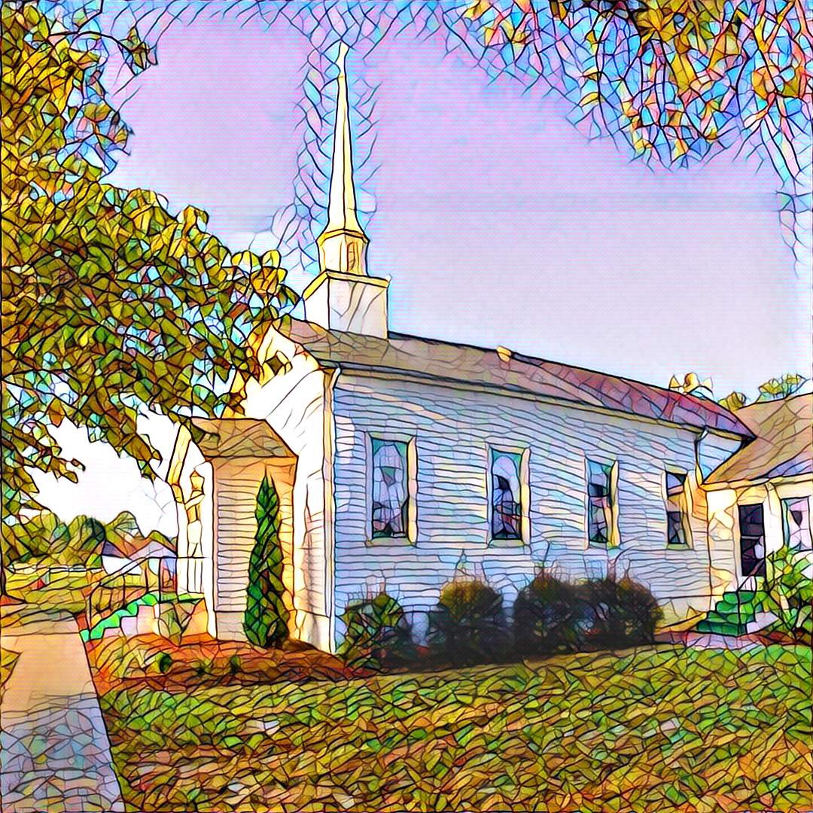

1459 White Memorial Church Road - Willow Spring, NC 27592
www:wmpcwillowspring.org

Remembering God’s Grace,

the mission of White Memorial Presbyterian Church in Willow Spring is:
Come to be joyous and thoughtful in worship;
Walk with God’s guidance into deeper faith and knowledge;
Stretch out to the needy with tangible acts of service;
Be loving and generous with time, talents and treasures;
Go out into the world to welcome and invite.
The Service for the Lord’s Day
Twenty-Second Sunday after Pentecost
White Memorial Presbyterian Church Homecoming

The Church Gathers
October 25, 2026 10:30 AM
*Please rise in body or spirit.

Prayer for Preparation:
Give thanks because the Lord Almighty is with us; the God of Jacob is our fortress.

Prelude –

Welcome and Announcements

*Call to Worship
All: We are here, with heart, soul and mind.
One: We gather here as Christ’s body.
All: We are neighbors, learning how to love each other.
One: The Holy Spirit gathers us in to be sent out again.
All: We are here to worship and to be transformed.
One: Let us worship the Triune God!

Opening Hymn - #412 God, Reveal Your Presence

Prayer of Adoration

Call to Confession

Confession and Pardon

Call to Confession

Prayer of Confession
All: Holy God, we are often good at following rules while neglecting the heart of your
commandments. We place ourselves in the congregation of the righteous, but take our seat
among the scoffers. We seek approval of our friends, family, and others whose opinions we
value, forgetting that our call is to please you, above all.
You call us to be holy, but we settle for self-righteousness.
You call us to be impartial, but we cannot shed our biases.
You call us to love our neighbors, but we have been satisfied to keep them at arm’s length.
You created us to love you with soul, heart, and mind, but we have held parts of ourselves
back. Have mercy on us, God. Watch over our ways, redirect our paths, and help us love you with abandon — heart, soul, and mind.
Make us instruments of reconciliation and transformation as we seek to follow your law of
love, made known to us in Jesus Christ. Amen.

Assurance of God’s Pardon
One: Hear the good news! The night is far gone, the day is near. Let us lay aside the works of darkness and put on the armor of light. In Jesus Christ, we are forgiven.
All: Thanks be to God. Amen.

We Proclaim God’s Word

Prayer for Illumination
All: Holy God, by the power of your Spirit, help us meditate on your law and commandments. As your Word is read today, help us be fully present – heart, soul, and mind – and show us your way of love. Amen.

Scripture Reading: Psalms 46: 7-11 Philippians 4: 12, 13

One: This is the Word of God for the people of God.
All: Thanks be to God

Sermon: - "Finding Peace In The Present Moment" John Etheredge, QRE

* Affirmation of Faith (from A Declaration of Faith)
All: We are certain that Jesus lives. He lives as God with us, touching all of human life with the presence of God. He lives as one of us with God. Because he shares our humanity and has bound us to himself in love, we have an advocate in the innermost life of God. We declare that Jesus is Lord. His resurrection is a decisive victory over the powers that deform and destroy human life. His lordship is hidden. The world appears to be dominated by people and systems that do not acknowledge his rule. But his lordship is real. It demands our loyalty and sets us free from the fear of all lesser lords who threaten us. We maintain that ultimate sovereignty now belongs to Jesus Christ in every sphere of life. Jesus is Lord. He has been Lord from the beginning. He will be Lord at the end. Even now he is Lord.

*Hymn of Response - #647 Give Thanks

Sharing of Joys and Concerns

Prayers of the People and the Lord’s Prayer
Our Father who art in heaven, hallowed be thy name. Thy kingdom come, thy will be done, on earth as it is in heaven. Give us this day our daily bread; and forgive us our debts, as we forgive our debtors; and lead us not into temptation but deliver us from evil. For thine is the kingdom and the power and the glory, forever. Amen

Reception of God’s Tithes and Our Offerings

Offertory

*Doxology

*Prayer of Dedication

Going Out in God’s Name

*Hymn of Commitment - #697 Take My Life

*Charge and Benediction

*Postlude

Leading in Worship today
John Etheredge, QRE
Anne Honeycutt

Nancy Warren, Commissioned Ruling Elder, flagman22@embarqmail.com
Staff- Charlene Wilson, Church Secretary, WMPCoffice@WMPCwillowspring.org
Upcoming Services at WMPC
November 1st Nancy Warren, CRE
November 8th John Etheredge,QRE
November 15th Rev.Jeff Kisner
November 22nd Rev. Joy Alford
November 29th Nancy Warren, CRE
Hanging of the Greens

Announcements

- Our next Nourish Worship is Tuesday, October 27th at 5:30 PM. All are welcome at the table!
- Presbyterian Women, Monday November 9th
- Senior lunch is Thursday, 12th November 12th at Mt. Zion. Please let Margaret King know if you plan to
attend

Public Prayer List
Prayer concerns may be submitted by turning in a prayer request card in the offering plate or by contacting Glenda Talton via phone or email.

Congregation:

Roger Gossett, Jan Gossett, Pat Patrick, Jim and Trish Shannon, Ann Stephenson, Jerry and Jane Smith, Linda Strickland, Teresa Smith, Becky and Ronnie Stephenson.
Mary Jane Dunn's eye surgery is scheduled for October 23rd.

Family/Friends:
Ruth Dupree, Paulette Greer (Margaret), Lee Anne Simmons (Anne Honeycutt), Darlene Martin (sister of Sharon Guss), Lissette and her autistic son are having difficulties(Sharon Guss), Pam Denning, Linda Penny (Don),Cathy Cotton (Carole), Rev. Joy Alford's friend Kelly's daughter, Lil Ortney (Don and Teresa). David Holt (Teresa), Michelle Martinez (Trish).
Marie Holding (Joyce Byrd’s sister) is back in the hospital.

Homecoming Sunday was delightful – seeing friends, beautiful music, meaningful worship and delicious lunch.

