White Memorial
Presbyterian Church

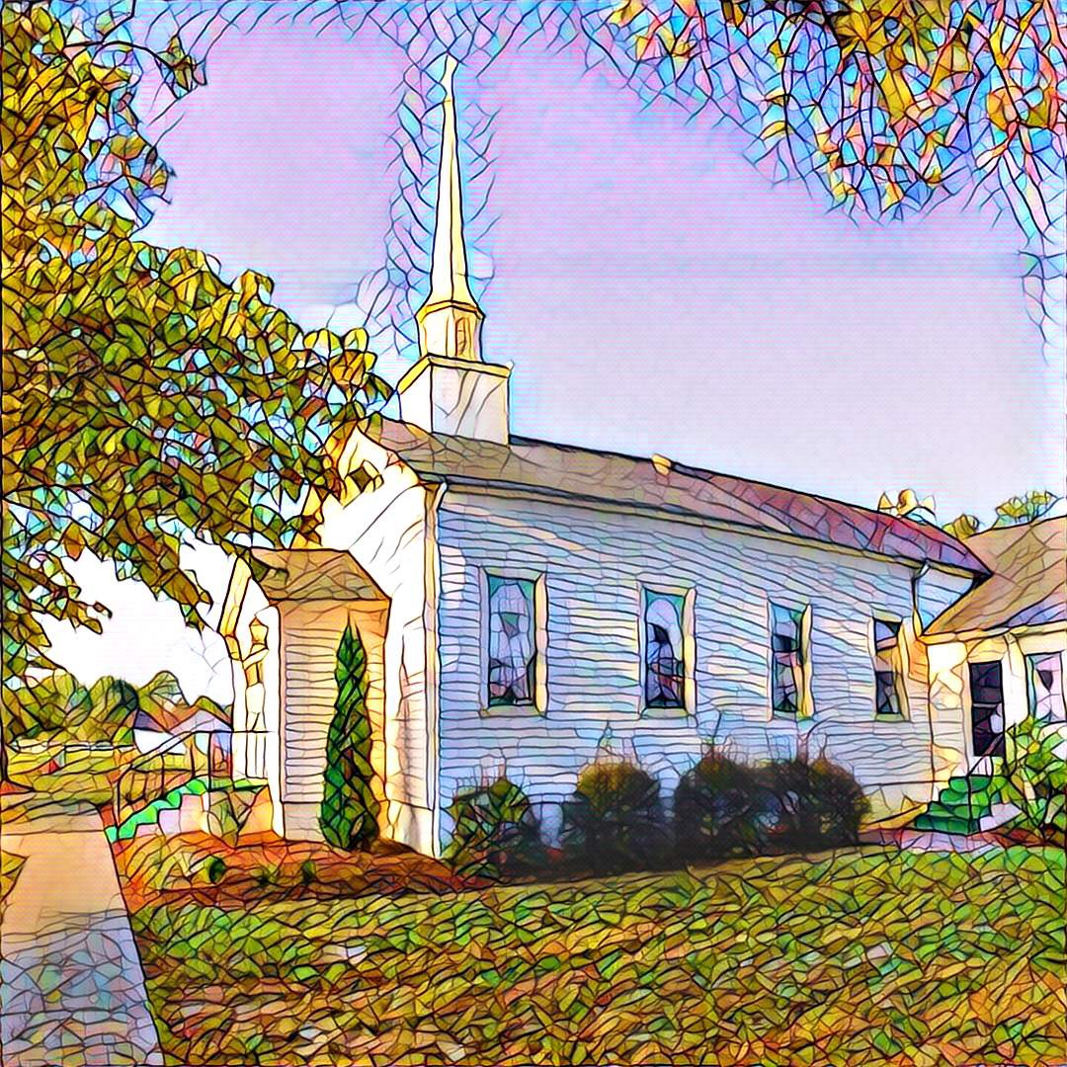

1459 White Memorial Church Road - Willow Spring, NC 27592
www:wmpcwillowspring.org

Remembering God’s Grace,

the mission of White Memorial Presbyterian Church in Willow Spring is:
Come to be joyous and thoughtful in worship;
Walk with God’s guidance into deeper faith and knowledge;
Stretch out to the needy with tangible acts of service;
Be loving and generous with time, talents and treasures;
Go out into the world to welcome and invite.
The Service for the Lord’s Day
Seventeenth Sunday after Pentecost

The Church Gathers
October 11, 2026 10:30 AM
*Please rise in body or spirit.

Prayer for Preparation:

Prelude

Welcome and Announcements

*Call to Worship
One: Sisters and Brothers, as Children of God, let us gather to renew the Spirit of God’s grace that
gives us heart and mind and soul and strength. Come to Sabbath’s rest and Worship’s growth.
All: We come to find the kingdom of God within us and amongst us. May we grow together in
faith and hope and caring, gathered as one in communion with Christ.
One: When we enter here, God enters with us. May it always be so.
All: When we leave, may we help all to know that God is with them, too. May it always be so.

* Affirmation of Faith - adapted from the Confessions of the Presbyterian Church USA
All: Loving God, in life and in death we belong to You. As Creator You give us grace and truth as the powers for life. As Savior You give us faith and hope and caring as the way of life. As Holy Spirit You give us communion, courage and joy as life’s blessings. With your gifts You strengthen us to love You, our neighbors and ourselves. With believers in every time and place, we rejoice that nothing in life or in death can separate us from Your love in Christ Jesus our Lord. As your family we pray, Amen.

*Opening Hymn – #32 I Sing the Mighty Power of God

Prayer of Adoration
Confession and Pardon

Call to Confession and Prayer of Confession
One: Neighbors, visitors, friends and all - as we are gathered in God's temple, in God’s image, in God's light, let us reflect on our lives and on the way of living that we've followed,
All: that we may find and share the blessed and holy way of God in Christ.
One: God of grace and graciousness, your power in life and your truth in Christ heal us from ignorant and hurtful ways.
All: Your grace & graciousness guide us to understanding & caring for all your children, our brothers, our sisters.
One: Here in the peace of your blessing, here in quiet reflection on our days and dreams and hopes,
All: May we follow your guidance and come to You and, in your holy Spirit, come to our own best selves.
One: A moment now for finding guidance in quiet conversation with our Lord. - (Silent Confession) Amen

Assurance of God’s Pardon
One: Family of God and Christ and their Holy Spirit, the good news for our days and lives is that God’s empowering grace is boundlessly, graciously given us for our own sake. As we have repointed our lives from error and harm to truth and care, know and feel the fullness of God’s grace, restored in us.
All: Thanks be to God, thanks be to Christ, thanks be to the Holy Spirit in our brothers & sisters on the way. Amen.

Scripture Reading #1 Genesis 1 & 2; Leviticus 19 Glenda Talton

Youth Message ADAM & EVE: BABIES OR GROWNUPS
Scripture Reading #2 Matthew 9, 10; John 13 Glenda Talton

Sermon GOD’S LABOR LAWS Jack Donovan

We Respond to God’s Word

*Hymn of Response #298 (v. 1,2,5) - Lord, You Give the Great Commission

Sharing of Joys and Concerns

Prayers of the People and the Lord’s Prayer
One: Gracious God, who knows us in our souls as you’ve given and in our spirits as we’ve lived,
All: we pray that by your grace we will fulfill your hopes for all you’ve conceived in us.
One: May we feel your presence as we celebrate the joys we share and the kindness we receive -
All: and may we know you are with us come joy or woe. Amen.
One: We have joys and concerns printed in the bulletin…. Are there any others you would like to add?
(One: After further sharing, we join in with The Lord’s Prayer.)
All: Our Father who art in heaven, hallowed be thy name. Thy kingdom come, thy will be done, on earth as it is in heaven. Give us this day our daily bread; and forgive us our debts, as we forgive our debtors; and lead us not into temptation but deliver us from evil. For thine is the kingdom and the power and the glory, forever. Amen

Reception of God’s Tithes and Our Offerings

Offertory

*Doxology

Prayer of Dedication
All: For Heaven within each and Heaven amongst all, may our offerings please God and help our world to thrive.

Going Out in God’s Name

*Hymn of Commitment #744 - Arise, Your Light is Come

*Charge and Benediction

Let us remember Jesus’ words to his followers as he leaves them with the counsel of Good News and of the Holy Spirit: Peace I leave with you; my peace I give to you. I do not give to you as the world gives. Do not let your hearts be troubled, and do not let them be afraid. …Arise, and let’s be on our way.

Postlude

Leading in Worship Today
Jack Donovan, QRE
Anne Honeycutt - Musician

Nancy Warren, Commissioned Ruling Elder, flagman22@embarqmail.com
Staff- Charlene Wilson, Church Secretary, WMPCoffice@WMPCwillowspring.org
Upcoming Services at WMPC
October 18th (Homecoming) Rev. Ed Johnson
October 25th John Etheredge
November 1st Nancy Warren, CRE
November 8th John Etheredge
November 15th Jeff Kisner
November 22nd Rev. Joy Alford
November 29th Rev. Willem Bodesco

Announcements

- Senior lunch is Thursday, 12th October at Mt. Zion. Please let Margaret King know if you plan to
attend
- Our next Nourish Worship is Tuesday, October 27th at 5:30 PM. All are welcome at the table!

Public Prayer List
Prayer concerns may be submitted by turning in a prayer request card in the offering plate or by contacting Glenda Talton via phone or email.

Congregation:

Roger Gossett, Jan Gossett, Pat Patrick, Jim and Trish Shannon, Ann Stephenson, Jerry Smith and Jane Smith, Linda Strickland, Teresa Smith, Becky and Ronnie Stephenson.
Mary Jane Dunn's eye surgery has been scheduled for October 23rd.

Family/Friends:
Ruth Dupree, Paulette Greer (Margaret), Lee Anne Simmons (Anne Honeycutt), Darlene Martin (sister of Sharon Guss), Lissette and her autistic son are having difficulties(Sharon Guss), Mary Jane Dunn – eye surgery on 10/23, Marie Holding – returned to her home, Pam Denning, Linda Penny (Don),Cathy Cotton (Carole, Mike Norris(Jenn), Rev. Joy Alford's friend Kelly's daughter – cancer,Terry Parrish (Sandy), Lil Ortney (Don and Teresa). David Holt (Teresa), Michelle Martinez (Trish), Kim Havens (Nancy),
Jerry Yarborough (Don), Michelle Martinez (Trish),Scott and Arthur from Indiana (Sharen & Gerry's friends).

Condolences for family and friends of Dana Benson Dillon who died after a battle with cancer.
Prayers for all others that may be known to us or unknown to us.

Prayers and condolences for Michelle Jones who recently lost her nephew.

Joys

Jenn's expecting a new grandbaby. Congratulations Jenn!!

Margaret King's birthday was Saturday, October 10th! Happy 88th Margaret!

