White Memorial
Presbyterian Church

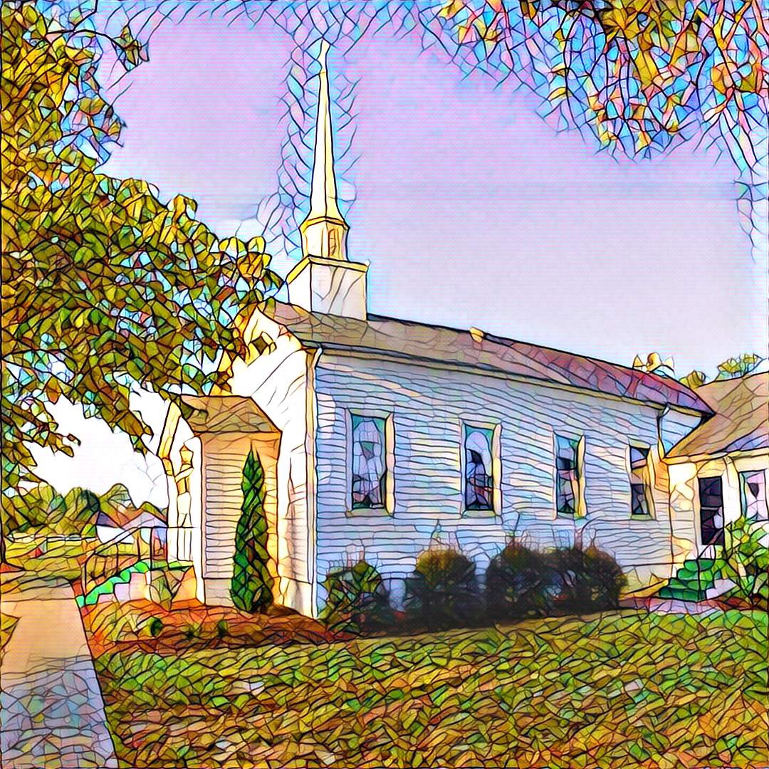

1459 White Memorial Church Road - Willow Spring, NC 27592
www:wmpcwillowspring.org

Remembering God’s Grace,

the mission of White Memorial Presbyterian Church in Willow Spring is:
Come to be joyous and thoughtful in worship;
Walk with God’s guidance into deeper faith and knowledge;
Stretch out to the needy with tangible acts of service;
Be loving and generous with time, talents and treasures;
Go out into the world to welcome and invite.
The Service for the Lord’s Day
All Saints Sunday
White Memorial Presbyterian Church Homecoming

The Church Gathers
November 1, 2026 10:30 AM
*Please rise in body or spirit.

Prayer for Preparation:
Give thanks because the Lord Almighty is with us; the God of Jacob is our fortress.

Prelude –

Welcome and Announcements

*Call to Worship
One: When our hope is dead from fear and doubt,
All: Jesus says to us, "Rise!"
One: When our souls are dead to the teachings of God's Words,
All: Jesus says to us, "Rise!"
One: When our eyes are blind to the needs of others,
All: Jesus says to us, "Rise!"
One: When our hearts are dead to the stirrings of Joy,
All: Jesus says to us, "Rise!" - Mary Katrina Boyd

Opening Hymn - #664 Morning Has Broken

Prayer of Adoration

Call to Confession
Let us confess our sin as an offering of our trust in God's love and forgiveness for us.

Confession and Pardon

Prayer of Confession
God of our restoration, whenever we come home to you we realize how far we have strayed and how much we have forgotten your law and your love. We have not love you with our whole hearts or loved our neighbors as ourselves. Forgive us, heal us, and restore us to our relationships with you; through Jesus Christ in whom we trust. (Silence for personal confession)

Assurance of God’s Pardon
God's word does not condemn us, but sets us free to live in peace with God and one another.

We Proclaim God’s Word

Prayer for Illumination
Your Word is a lamp to our feet and a light to our path. Psalm 119

Scripture Reading: Psalter: Psalm 34: 1-20; Revelation 7:9-17; Matthew 5:1-12

Sermon: - “We Are the Saints of God?” Rev. Carole McCartney

* Affirmation of Faith (from A Declaration of Faith)

All: We are certain that Jesus lives. He lives as God with us, touching all of human life with the presence of God. He lives as one of us with God. Because he shares our humanity and has bound us to himself in love, we have an advocate in the innermost life of God. We declare that Jesus is Lord. His resurrection is a decisive victory over the powers that deform and destroy human life. His lordship is hidden. The world appears to be dominated by people and systems that do not acknowledge his rule. But his lordship is real. It demands our loyalty and sets us free from the fear of all lesser lords who threaten us. We maintain that ultimate sovereignty now belongs to Jesus Christ in every sphere of life. Jesus is Lord. He has been Lord from the beginning. He will be Lord at the end. Even now he is Lord.

*Hymn of Response - #525 Let Us Break Bread Together - verses 1 and 2

Sharing of Joys and Concerns

Prayers of the People

Reception of God’s Tithes and Our Offerings

Offertory

*Doxology

*Prayer of Dedication

We Joyously Gather At Our Lord’s Table
Invitation to the Table

The Great Prayer of Thanksgiving
One: The Lord be with you.
All: And also with you.
One: Lift up you hearts.
All: We lift them to the Lord.
One: Let us give thanks to the Lord our God.
All: It is right to give our thanks and praise.

Prayer of Thanksgiving continues….
All: Holy, holy holy Lord, God of power and might, heaven and earth are full of your glory. Hosanna in the highest, blessed is he who comes in the name of the Lord. Hosanna in the highest.

Prayer of Thanksgiving continues…
All: Christ has died, Christ is risen, Christ will come again.

The Words of Institution

Communion by intinction

Prayer after Communion and Lord’s Prayer
All: We thank you, O God, that through Word and Sacrament you have given us your Son, who is the true bread from heaven and good of eternal life. So strengthen us in you service that our daily living may show our thankful praise; through Jesus Christ our Lord. Amen.

All: Our Father who art in heaven, hallowed be thy name. Thy kingdom come, thy will be done, on earth as it is in heaven. Give us this day our daily bread; and forgive us our debts, as we forgive our debtors; and lead us not into temptation, but deliver us from evil. For thine is the kingdom and the power and the glory, forever. Amen.

Going Out in God’s Name

*Hymn of Commitment - #192 - Lord, the Light of Your Love is Shining

*Charge and Benediction

*Postlude

Leading in Worship today
Rev. Carole McCartney
Anne Honeycutt, Musician

Nancy Warren, Commissioned Ruling Elder, flagman22@embarqmail.com
Staff- Charlene Wilson, Church Secretary, WMPCoffice@WMPCwillowspring.org
Upcoming Services at WMPC
November 8th John Etheredge,QRE
November 15th Rev.Jeff Kisner
November 22nd Rev. Joy Alford
November 29th Nancy Warren, CRE
Hanging of the Greens

Announcements

- Presbyterian Women will meet at noon on Monday, November 9, in the fellowship hall. Please bring a covered dish to share for lunch.
- Senior lunch is Thursday, 12th November 12th at Mt. Zion. Please let Margaret King know if you plan to
attend

- Our next Nourish Worship is Tuesday, November 24th at 5:30 PM. All are welcome at the table!

Public Prayer List
Prayer concerns may be submitted by turning in a prayer request card in the offering plate or by contacting Glenda Talton via phone or email.

Congregation:

Roger Gossett, Jan Gossett, Pat Patrick, Jim and Trish Shannon, Ann Stephenson, Jerry and Jane Smith, Linda Strickland, Teresa Smith, Becky and Ronnie Stephenson, Sandy Parrish, Nancy Warren,Mary Jane Dunn's eye surgery was successful,

Family/Friends:
Ruth Dupree, Paulette Greer (Margaret), Lee Anne Simmons (Anne Honeycutt), Darlene Martin (sister of Sharon Guss), Lissette and her autistic son are having difficulties(Sharon Guss), Pam Denning, Linda Penny (Don),Cathy Cotton (Carole), Rev. Joy Alford's friend Kelly's daughter, Lil Ortney (Don and Teresa). David Holt (Teresa), Michelle Martinez (Trish).

Marie Holding (Joyce Byrd’s sister) did require and additional back surgery and will be returning to BellaRose in Garner for rehab.

