White Memorial
Presbyterian Church

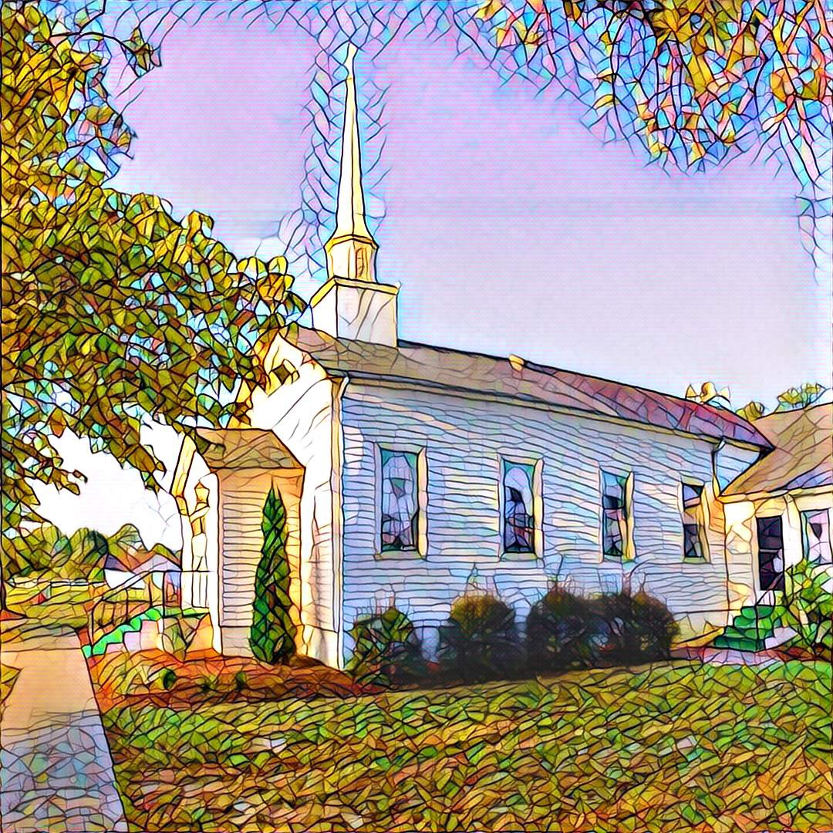

1459 White Memorial Church Road - Willow Spring, NC 27592
www:wmpcwillowspring.org

Remembering God’s Grace,

the mission of White Memorial Presbyterian Church in Willow Spring is:
Come to be joyous and thoughtful in worship;
Walk with God’s guidance into deeper faith and knowledge;
Stretch out to the needy with tangible acts of service;
Be loving and generous with time, talents and treasures;
Go out into the world to welcome and invite.
The Service for the Lord’s Day
Fourteenth Sunday after Pentecost

The Church Gathers
August 30, 2026 10:30 AM

*Please rise in body or spirit.

Prayer for Preparation:
We say, “Who am I that I should go to Pharaoh and bring the Israelites out of Egypt?” God says, “I will be with you.” (from Exodus 3)

Prelude

Welcome and Announcements

*Call to Worship
One: Seek the Lord! Seek God in the wilderness.
All: Seek God in the sanctuary.
One: Seek God in the burning bush.
All: Seek God in the burning heart.
One: The Lord is here! This place is holy!
All: We are standing on holy ground.

*Opening Hymn – #96 Brethren, We Have Met to Worship

Prayer of Adoration
Confession and Pardon
Call to Confession

Prayer of Confession
All: God of wonders, we confess that we do not understand why you call us when we are scared, clumsy, busy or flawed. We confess that we think we know better than you do who is qualified to do your work. Forgive our fears and excuses and self-doubts. Lend us your fire and your strength, as we go about the work of serving our neighbors, building up your church, loving your children, and tending to the scorched places of our world. Help us to burn for you, without burning up or burning out. Give us a purpose and the courage to pursue it. We ask this in Jesus’ name. Amen.

Assurance of God’s Pardon
One: Hear the good news! New life rises from the ashes. In Christ, your sins are dead and you are alive to all that is good.
All: In Christ, we are made whole; in Christ, we are forgiven. Alleluia! Amen.

We Proclaim God’s Word
Prayer for Illumination
All: Lord, open our hearts and minds by the power of your Holy Spirit to hear the Word proclaimed.

Scripture Reading - Isaiah 6: 4-8 and Mark 1: 16-20.

Sermon "Jesus Is Calling You To Ministry." John Etheredge

We Respond to God’s Word
*Affirmation of Faith – Apostle’s Creed
All: I believe in God the Father Almighty, Maker of heaven and earth, and in Jesus Christ his only Son our Lord; who was conceived by the Holy Ghost, born of the Virgin Mary, suffered under Pontius Pilate, was crucified, dead, and buried; he descended into hell; the third day he rose again from the dead; he ascended into heaven, and sitteth on the right hand of God the Father Almighty; from thence he shall come to judge the quick and the dead. I believe in the Holy Ghost; the holy catholic Church; the communion of saints; the forgiveness of sins; the resurrection of the body; and the life everlasting. Amen

*Hymn of Response –# 720 Jesus Calls Us

Sharing of Joys and Concerns

Prayers of the People and the Lord’s Prayer
Our Father who art in heaven, hallowed be thy name. Thy kingdom come, thy will be done, on earth as it is in heaven. Give us this day our daily bread; and forgive us our debts, as we forgive our debtors; and lead us not into temptation but deliver us from evil. For thine is the kingdom and the power and the glory, forever. Amen

Reception of God’s Tithes and Our Offerings

Call for the Offering
Offertory

*Doxology

Prayer of Dedication
Going Out in God’s Name

*Hymn of Commitment – #721 Lord, You Have Come to the Lakeshore

*Charge and Benediction

Postlude

Leading in Worship Today
John Etheridge
Anne Honeycutt - Musician

Nancy Warren, Commissioned Ruling Elder, flagman22@embarqmail.com
Staff- Charlene Wilson, Church Secretary, WMPCoffice@WMPCwillowspring.org

Announcements

- Senior lunch is Thursday, September 10th hosted by Overflow @ WMPC. Please let Margaret King know if you plan to attend. Also, for those attending please bring a food donation for the Pantry.
- Our next Nourish Worship is this Tuesday, September 22nd at 5:30 PM. All are welcome at the table!

Presbyterian Women's Study

The study session."United Through Christ, Bound to Each Other"
Monday, Sept 14th at Noon WMPC fellowship hall. Lunch will be a potluck – please bring a dish to share

Public Prayer List
Prayer concerns may be submitted by turning in a prayer request card in the offering plate or by contacting or Glenda Talton via phone or email.

Congregation:

Roger Gossett, Jan Gossett, Pat Patrick, Jim and Trish Shannon, Ann Stephenson, Jerry Smith and Jane Smith, Linda Strickland, Teresa Smith.

Family/Friends:
Ruth Dupree, Lisa Dove (Anne H.), recovering from surgery. Paulette Greer (Margaret), Lil Ortley, Lou Ann and Michael Payne (Glenda & Lee),David Penny, Damien Perez (friend of Nancy and Charlene), Lee Anne Simmons (Anne Honeycutt), Carol Kyser (Nancy Warren)

Marie Holding has been moved to BellaRose for rehab.

Prayers for the family and friends of Gail Gordon Musser who passed away on August 26^{t}. She will be
buried here at White Memorial.
Pat Patrick – has a new address: Calyx Living, 121 East Academy Street, B-5, Fuquay-Varina, NC 27526
Joys:
Congratulations to Jenn Baudoux on her new job at Carolina Pottery!

