White Memorial
Presbyterian Church

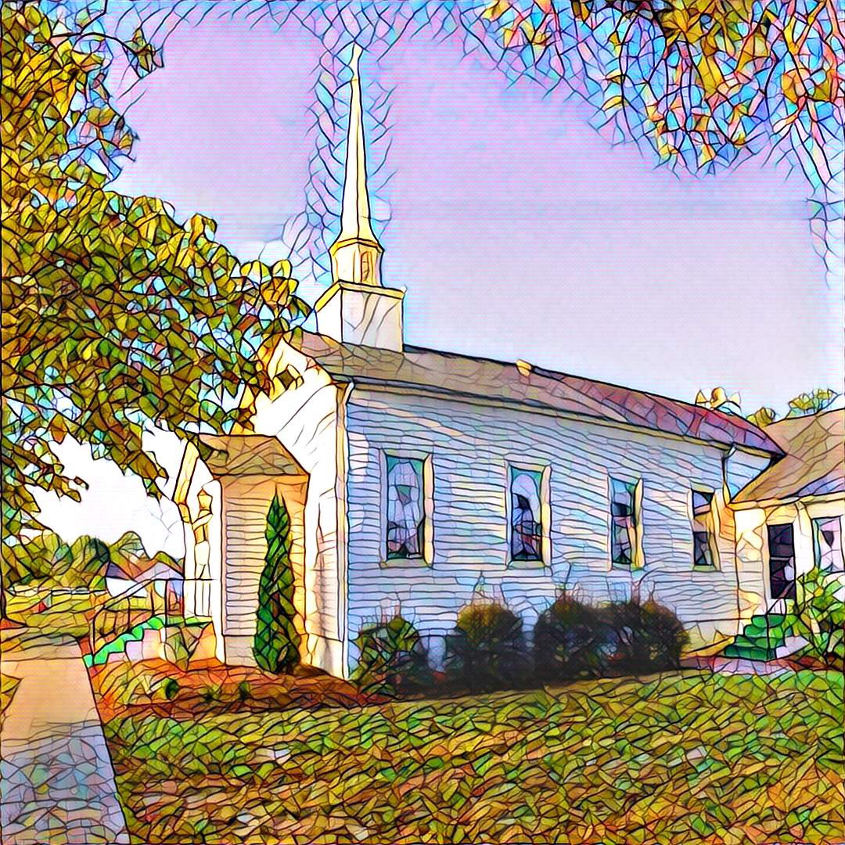

1459 White Memorial Church Road - Willow Spring, NC 27592
www:wmpcwillowspring.org

Remembering God’s Grace,

the mission of White Memorial Presbyterian Church in Willow Spring is:
Come to be joyous and thoughtful in worship;
Walk with God’s guidance into deeper faith and knowledge;
Stretch out to the needy with tangible acts of service;
Be loving and generous with time, talents and treasures;
Go out into the world to welcome and invite.
The Service for the Lord’s Day
Thirteenth Sunday after Pentecost

The Church Gathers
August 23, 2026 10:30 AM

Prayer for Preparation:
It is good to know what others believe about Jesus, but it is more important for us to know what we believe about Jesus, and how he is the Christ for us. (William H. Schein)

Prelude -“I Am Thine O Lord” by Fanny Crosby

Welcome and Announcements

*Call to Worship
One: We see Jesus as Mary’s son, as God, God’s holy Son
All: We see Jesus as the Christ of God, the life, the truth, the way.
One: We open our ears to hear his call, “Follow me!”
All: Christ, we are yours; we give ourselves to you.

*Opening Hymn – # 363 "the Lord is King!"

Prayer of Adoration
Confession and Pardon
Call to Confession

Prayer of Confession
All: Holy and merciful God, in your presence we confess our failure to be what you created us to be. We wander from your ways, waste your gifts and forget your love. By your loving mercy, help us to live in your light and abide in your ways, for the sake of Jesus Christ our Savior.

Assurance of God’s Pardon

We Proclaim God’s Word
Prayer for Illumination
All: Lord, open our hearts and minds by the power of your Holy Spirit to hear the Word proclaimed.

Scripture Reading- Exodus 1:8-2:10; Romans 12:1-8; Matthew 16:13-20

Sermon –“Transformed” Rev. Carole McCartney

We Respond to God’s Word
*Affirmation of Faith – Apostle’s Creed
All: (from A Brief Statement of Faith)
In a broken and fearful world, the Spirit gives us courage to pray without ceasing, to witness among all peoples to Christ as Lord and Savior, to unmask idolatries in Church and culture, to hear the voices of peoples long silenced, and to work with others for justice, freedom, and peace. In gratitude to God, empowered by the Spirit, we strive to serve Christ in our daily tasks and to live holy and joyful lives, even as we watch for God’s new heaven and new earth, praying, “Come, Lord Jesus!”

*Hymn of Response –# 364 “Lift Up the Gates Eternal”

Sharing of Joys and Concerns

Prayers of the People and the Lord’s Prayer
Our Father who art in heaven, hallowed be thy name. Thy kingdom come, thy will be done, on earth as it is in heaven. Give us this day our daily bread; and forgive us our debts, as we forgive our debtors; and lead us not into temptation, but deliver us from evil. For thine is the kingdom and the power and the glory, forever. Amen

Reception of God’s Tithes and Our Offerings

Call for the Offering
Offertory “Redeemed” by Fanny Crosby

*Doxology

Prayer of Dedication

Going Out in God’s Name

Hymn of Commitment – #451 "Open My Eyes,That I May See"

*Charge and Benediction

Postlude

Leading in Worship Today
Rev Carole McCartney
Kristy Gathings, Musician

Nancy Warren, Commissioned Ruling Elder, flagman22@embarqmail.com
Staff- Charlene Wilson, Church Secretary, WMPCoffice@WMPCwillowspring.org

Announcements

- Senior lunch is Thursday, September 10th hosted by Overflow @ WMPC. Please let Margaret King know if you plan to attend. Also, for those attending please bring a food donation for the Pantry.
- Our next Nourish Worship is this Tuesday, August 25th at 5:30 PM. All are welcome!

Presbyterian Women's Study
The study session."United Through Christ, Bound to Each Other"
Monday, Sept 14th at Noon WMPC fellowship hall. Lunch will be a potluck – please bring a dish to share

Upcoming Services at WMPC

- August 30th John Etheridge

Public Prayer List
Prayer concerns may be submitted by turning in a prayer request card in the offering plate or by contacting or Glenda Talton via phone or email.

Congregation:

Roger Gossett, Jan Gossett, Pat Patrick, Jim and Trish Shannon, Ann Stephenson, Jerry Smith and Jane Smith, Linda Strickland, Teresa Smith.
Marie Holding (Joyce's sister) will be going to BellaRose in Garner for rehab after a recent fall.

Family/Friends:
Ruth Dupree, Lisa Dove (Anne H.), recovering from surgery. Paulette Greer (Margaret), Lil Ortley, Lou Ann and Michael Payne (Glenda & Lee),David Penny, Damien Perez (friend of Nancy and Charlene), Lee Anne Simmons (Anne Honeycutt), Carol Kyser (Nancy Warren)

Prayers for the friends and family of Doug Barnes, Joan's friend, who passed away.
Rev. Williem Bodesco Massink's sister-in-law recently passed away unexpectantly.

Joys
- Prayers and Joy for students as they begin a new school year this week!!
- Truman Talton has begun classes at Wake Tech - congratulations Truman!
- Successful Neighborhood Block Party on Saturday. Thanks to everyone for their help.

