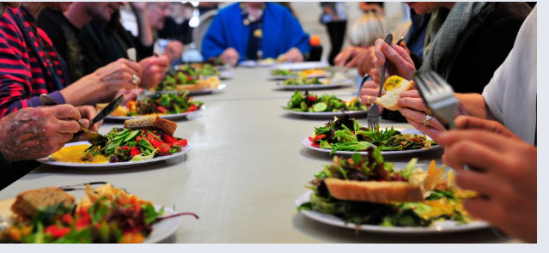**Welcome to our Table**

**Join us for**

**NourishWorship**

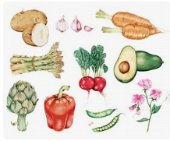 **@ White Memorial Presbyterian Church, Willow Spring**

**As we gather to bring our community together in the**

**spirit of fellowship and Christian love. As we enjoy great food, speak about God’s love in our lives and enjoy what being a connected community**

**can mean to us all.**

***4th Tuesday every month @ 5:30 in the fellowship hall***

***1459 White Memorial Church Road - Willow Spring, NC 27592***

[***Or Visit us on Facebook!***](https://www.facebook.com/WhiteMemorialPresbyterianChurchWillowSpring/)